PROJECT DOCUMENTATION
Last-Mile Delivery Tracker
A Role-Based Delivery Management Platform with Automated Pricing, Intelligent Agent Assignment & Real-Time Order Tracking
MERN Stack — MongoDB · Express.js · React (Vite) · Node.js · Tailwind CSS · JWT Auth
Candidate Name: Vaishnavi Ashok Ubarhande
Roll No. / Registration No.: 23BCE11488
College / Institute: Vellore Institute of Technology Bhopal
Date: 24 August 2026

Table of Contents
1. Project Objective & Overview | 3
1.1 Problem Statement | 3
1.2 Objective | 3
2. Scope of Work | 3
2.1 Inputs | 3
2.2 Outputs | 3
2.3 Functional Scope | 4
3. Technology Stack & Architecture | 4
3.1 Stack | 4
3.2 High-Level Architecture | 4
3.3 Project Structure | 5
4. Database Schema | 5
4.1 User | 5
4.2 Zone | 5
4.3 RateCard | 5
4.4 Order | 5
5. Rate Calculation Engine | 6
6. Zone Detection | 6
7. Auto-Assignment Logic | 6
8. Order Status Lifecycle & Failed Delivery Handling | 7
8.1 Status Lifecycle | 7
8.2 Failed Delivery & Reschedule Flow | 7
9. API Documentation | 7
9.1 Authentication | 7
9.2 Zones (Admin-Configurable) | 8
9.3 Rate Cards (Admin-Configurable) | 8
9.4 Users / Agents | 8
9.5 Orders | 8
9.6 Sample Request — Price Preview | 9
10. Testing Strategy | 9
11. Setup & Installation Guide | 9
11.1 Prerequisites | 9
11.2 Backend | 10
11.3 Frontend | 10
11.4 Seeded Test Accounts | 10
12. Deployment | 10
13. Key Design Decisions | 10
14. Application Screenshots | 11
15. Conclusion | 14

1. Project Objective & Overview
Logistics operations involve complex pricing rules, dynamic agent assignment, and reliable customer communication. The Last-Mile Delivery Tracker is a full-stack, role-based delivery management platform where customers and administrators can create orders with auto-calculated shipping charges, delivery agents are assigned intelligently (manually or via a nearest-available auto-assignment engine), and customers are kept informed at every stage of the delivery journey through email and SMS notifications.
The core design principle behind the system is that no pricing, zone, or assignment rule is hardcoded in application code. All of it is modelled as admin-editable data in the database, so operational changes (new rate cards, new zones, surcharge changes) never require a code change or redeployment.

1.1 Problem Statement
- Manual or spreadsheet-based delivery pricing is error-prone and cannot scale across B2B/B2C order types, multiple zones, and COD surcharges.
- Agent assignment is often done ad-hoc, leading to uneven workload and delayed pickups.
- Customers lack visibility into their shipment status and have no structured way to reschedule failed deliveries.
- Businesses need an auditable, timestamped history of every status change for dispute resolution and operational review.

1.2 Objective
Build a platform where:
- Customers and admins can create orders with an auto-calculated charge shown before confirmation.
- Agents are assigned intelligently — manually by an admin, or automatically to the nearest available agent.
- Every order status change is logged immutably and customers are notified by email at each step.
- Failed deliveries can be rescheduled, with the agent automatically reassigned for the new attempt.

2. Scope of Work

2.1 Inputs
- Pickup & drop address (with pincode / city)
- Package dimensions — Length × Breadth × Height (cm)
- Actual weight (kg)
- Order type — B2B or B2C
- Payment type — Prepaid or COD

2.2 Outputs
- An order record with an auto-calculated, itemised charge
- Agent assignment (manual or automatic)
- Live status tracking with a full, timestamped history
- Email/SMS notification on every status change

2.3 Functional Scope
- Admin manages delivery zones and maps pincodes/areas to each zone.
- Admin configures rate cards — separate intra-zone and inter-zone rates for B2B and B2C — plus a COD surcharge per order type.
- Customers can register, log in, and place orders; admins can also create an order on behalf of a customer.
- On order creation the system detects the pickup and drop zones, computes volumetric weight, bills on the higher of actual vs. volumetric weight, applies the correct rate card, and adds a COD surcharge where applicable — with the price shown before the customer confirms.
- Admin can manually assign an agent or trigger auto-assignment to the nearest available agent.
- Delivery agents update order status: Picked Up → In Transit → Out for Delivery → Delivered / Failed.
- On a failed delivery, the customer is notified and can reschedule for a new date; the agent is reassigned for the rescheduled attempt.
- Customers can view live status and the full tracking timeline for their orders.
- Admins can view all orders, filter by status/zone/agent, and override any order's status with an audit note.

3. Technology Stack & Architecture

3.1 Stack
Layer | Technology
Frontend | React 18 (Vite), Tailwind CSS, Axios
Backend | Node.js, Express.js
Database | MongoDB (Mongoose ODM)
Authentication | JWT (JSON Web Tokens), role-based access control
Notifications | Nodemailer (Email) + Twilio (SMS) — free-tier services, with a dry-run/console mode
Testing | Jest + Supertest, mongodb-memory-server (in-process DB, no external dependency)
Deployment targets | Vercel (frontend), Render/Railway (backend), MongoDB Atlas (database)

3.2 High-Level Architecture
The application follows a standard three-tier architecture: a React single-page application (SPA) communicates over REST with an Express API, which persists data in MongoDB. Role-based auth (customer / delivery agent / admin) is enforced via JWT middleware on every protected route. Four core logic modules — the rate calculation engine, zone detector, auto-assignment engine, and notification service — are implemented as isolated utility modules independent of the HTTP layer, so they are unit-testable and reusable across multiple endpoints (e.g. the price-preview and order-creation endpoints share the exact same pricing function, so a previewed price can never drift from the charged price).

3.3 Project Structure
lastmile-delivery-tracker/
├── backend/
│ ├── config/db.js MongoDB connection
│ ├── models/ User, Zone, RateCard, Order
│ ├── controllers/ auth, zone, rateCard, order, user
│ ├── routes/ REST route definitions
│ ├── middleware/ JWT auth + role guard, errors
│ ├── utils/
│ │ ├── rateCalculator.js volumetric/billable weight, charge
│ │ ├── zoneDetector.js pincode/city -> zone lookup
│ │ ├── autoAssign.js nearest-available-agent engine
│ │ └── notificationService.js Email + SMS
│ ├── seed/seed.js seeds admin, zones, rates, agents
│ ├── tests/ Jest unit + Supertest integration
│ └── server.js
├── frontend/
│ └── src/
│ ├── api/ axios client + endpoint wrappers
│ ├── context/AuthContext.jsx JWT session state
│ ├── components/ Navbar, StatusBadge, Timeline
│ └── pages/ Login, Register, Dashboards
├── SYSTEM_DESIGN.md
├── API_DOCUMENTATION.md
└── README.md

4. Database Schema
Four core Mongoose collections model the entire domain:

4.1 User
- role: customer | agent | admin
- Agents additionally carry an agentProfile: isAvailable, currentLocation (lat/lng), assigned zone, and activeOrderCount (used for load-balanced auto-assignment).

4.2 Zone
- Admin-defined; maps a list of pincodes (and optional area names) to a zone name.
- A pincode may belong to only one active zone at a time — enforced in the controller to prevent ambiguous zone assignment.

4.3 RateCard
- One active document per orderType (B2B / B2C): baseFare, baseWeightKg, perKgIntraZone, perKgInterZone, codSurchargeType (flat/percentage), codSurchargeValue.
- Fully admin-editable through the Admin dashboard — nothing pricing-related is hardcoded in application code.

4.4 Order
- Pickup/drop address with the detected zone, package dimensions, computed volumetricWeightKg / billableWeightKg.
- A frozen charge snapshot (baseFare, weightCharge, codSurcharge, totalCharge, and a reference to the RateCard used) — so historical orders retain their original price even if rate cards change later.
- Current status, assignedAgent, and a failedDelivery sub-object (reason, reschedule date, previous agent).
- An append-only trackingHistory[] array — each entry records status, actor {id, role, name}, note, and timestamp. Entries are only ever pushed, never edited or removed, forming a durable, timestamped audit trail of the full order lifecycle.

5. Rate Calculation Engine
Pricing is deliberately split into two collections — Zone (pincode-to-zone mapping) and RateCard (per order-type pricing rules) — so an admin changes a price by editing a document, never by editing code. The calculation is a strict, five-step pipeline implemented in rateCalculator.js:
- Zone detection: the pickup and drop pincode are looked up against the Zone collection; city name is used as a fallback if no pincode match exists.
- Volumetric weight: (Length × Breadth × Height in cm) ÷ 5000 — the industry-standard courier divisor.
- Billable weight: max(actualWeightKg, volumetricWeightKg) — protecting the platform from underpricing large, light packages.
- Rate card lookup: the active RateCard for the order's orderType (B2B/B2C) is fetched. If none exists, the engine throws a 422 error rather than silently defaulting to zero, treating an unconfigured rate card as a data-integrity error.
- Weight charge: max(0, billableWeight − baseWeightKg) × (perKgIntraZone or perKgInterZone), chosen by comparing pickup and drop zone IDs for equality.
- COD surcharge: added only when paymentType = COD, as either a flat amount or a percentage of (baseFare + weightCharge), per the rate card's codSurchargeType.
- Total = baseFare + weightCharge + codSurcharge.
This exact breakdown is returned by the POST /orders/preview endpoint before the customer confirms, and is re-computed — never trusted from the client — at order-creation time, so the confirmed price can never be spoofed by the frontend and always matches what the customer approved.

6. Zone Detection
Zone detection is a lookup, not a computation: given an address, the system queries Zone.findOne({ pincodes: address.pincode }), falling back to a case-insensitive match on area/city names if no pincode is mapped. This keeps the detection logic trivial while pushing all real-world geographic knowledge into admin-managed data — the only sustainable approach given that pincode-to-zone mappings change over time and vary by deployment region. If a pincode has no mapping at all, order creation fails fast with a clear error identifying exactly which pincode needs mapping, rather than silently defaulting to a zone and mis-pricing the order.

7. Auto-Assignment Logic
The nearest-available-agent engine (autoAssign.js) selects an agent in three tiers:
- Candidate pool = agents with isAvailable = true whose assigned zone matches the order's pickup zone.
- If candidates report a currentLocation, they are ranked by Haversine (great-circle) distance to the pickup address; the nearest wins, with ties (or agents lacking location data) broken by the lowest activeOrderCount — a simple load-balancing signal.
- If zero agents are available in the pickup zone, the search widens to all available agents system-wide so the order is never left unassignable; the response flags widenedSearch: true so the admin dashboard can surface it as an operational warning.
On every assignment, the previous agent's activeOrderCount (if reassigning) is decremented and the new agent's is incremented — this same counter both measures live workload and deprioritises an already-busy agent in future assignment decisions.

8. Order Status Lifecycle & Failed Delivery Handling

8.1 Status Lifecycle
Created → Assigned → Picked Up → In Transit →
Out for Delivery → Delivered
↳ Failed → Rescheduled → Assigned → ...
Any state (via admin) → Cancelled
Order status is governed by an explicit state machine (STATUS_TRANSITIONS in orderController.js), so an agent cannot, for example, jump straight from Assigned to Delivered — invalid transitions are rejected with a 400 response. Every transition appends an entry to Order.trackingHistory: { status, actor: {id, role, name}, note, timestamp }. This array is append-only and is the single source of truth for both the customer-facing tracking timeline and admin audit review.

8.2 Failed Delivery & Reschedule Flow
- An agent marks an order Failed with a reason — failedDelivery.isFailed / reason / failedAt are set, the customer is notified by email and SMS, and the tracking history is appended.
- The customer (or admin) calls the reschedule endpoint with a new date — the order moves to Rescheduled, failedDelivery.rescheduledDate is set, and the system immediately re-runs the same auto-assignment engine used for fresh orders, appending both a Rescheduled and an Assigned tracking entry.
- The agent then progresses the order through Picked Up → In Transit → Out for Delivery → Delivered/Failed again, exactly as with a fresh order.

9. API Documentation
Base URL (local): http://localhost:5000/api. All protected routes require the header Authorization: Bearer <JWT>. Successful responses use the envelope { success: true, data: ... }; errors use { success: false, message: ... }.

9.1 Authentication
Method & Route | Access | Description
POST /auth/register | Public | Registers a new customer account
POST /auth/login | Public | Logs in any role (customer/agent/admin)
GET /auth/me | Private | Returns the current authenticated user

9.2 Zones (Admin-Configurable)
Method & Route | Access | Description
GET /zones | Private (any role) | Lists all zones
GET /zones/:id | Private | Gets one zone
POST /zones | Admin only | Creates a zone; fails if a pincode is already mapped
PUT /zones/:id | Admin only | Partial update with the same conflict check
DELETE /zones/:id | Admin only | Soft-deletes a zone (isActive = false)

9.3 Rate Cards (Admin-Configurable)
Method & Route | Access | Description
GET /rate-cards | Private | Lists all rate cards (B2B, B2C)
POST /rate-cards | Admin only | Upserts the rate card for an orderType

9.4 Users / Agents
Method & Route | Access | Description
GET /users?role=agent | Admin only | Lists users, optionally filtered by role
POST /users | Admin only | Creates an agent or admin account
PUT /users/:id/agent-profile | Admin / self (agent) | Updates availability and/or current location
PUT /users/:id/active | Admin only | Activates/deactivates a user account

9.5 Orders
Method & Route | Access | Description
POST /orders/preview | Customer / Admin | Computes & returns price without creating an order
POST /orders | Customer / Admin | Creates the order; server re-computes the price
GET /orders?status=&zone=&agent= | Role-scoped | Lists orders (own / assigned / all, with admin filters)
GET /orders/:id | Owner / assigned agent / admin | Returns the full order incl. trackingHistory
PUT /orders/:id/assign | Admin only | Manually assigns a specific agent
PUT /orders/:id/auto-assign | Admin only | Triggers the nearest-available-agent engine
PUT /orders/:id/status | Assigned agent / admin | Advances the order through its lifecycle
PUT /orders/:id/reschedule | Owner / admin | Valid only when Failed; reassigns an agent
PUT /orders/:id/override | Admin only | Forces the order to any valid status with an audit note

9.6 Sample Request — Price Preview
POST /orders/preview
{
"pickupAddress": { "pincode": "110001", "city": "Delhi" },
"dropAddress": { "pincode": "560001", "city": "Bengaluru" },
"dimensions": {
"lengthCm": 30, "breadthCm": 20,
"heightCm": 10, "actualWeightKg": 2
},
"orderType": "B2C",
"paymentType": "COD"
}
Response 200:
{
"data": {
"pickupZone": { "id": "...", "name": "North" },
"dropZone": { "id": "...", "name": "South" },
"isIntraZone": false,
"volumetricWeightKg": 1.2,
"billableWeightKg": 2,
"charge": {
"baseFare": 40, "weightCharge": 37.5,
"codSurcharge": 20, "totalCharge": 97.5
}
}
}

10. Testing Strategy
The backend test suite uses Jest with Supertest, run against mongodb-memory-server — an in-process MongoDB instance — so tests require no external database. Two layers are covered:
- Unit tests for the rate calculation engine: volumetric weight, intra-zone vs. inter-zone pricing, and COD surcharge computation.
- An end-to-end integration test of the full order lifecycle: create → assign → status transitions → failed delivery → reschedule → auto-reassignment → admin override — asserting that the tracking history is appended correctly at every step.
Run with: npm test (from the backend/ directory).

11. Setup & Installation Guide

11.1 Prerequisites
- Node.js 18+
- MongoDB (local install, or a free MongoDB Atlas cluster)
- (Optional) SMTP credentials for real email and a free Twilio trial account for real SMS — without these, NOTIFICATIONS_DRY_RUN=true logs notifications to the console instead, and the rest of the app works fully.

11.2 Backend
cd backend
cp .env.example .env
# set MONGO_URI, JWT_SECRET, (optional) SMTP/Twilio
npm install
npm run seed
# creates admin, 2 zones, 2 rate cards, 2 agents, 1 customer
npm run dev
# starts on http://localhost:5000

11.3 Frontend
cd frontend
cp .env.example .env
# set VITE_API_BASE_URL=http://localhost:5000/api
npm install
npm run dev
# starts on http://localhost:5173

11.4 Seeded Test Accounts
Role | Email | Password
Admin | admin@lastmile.com | Admin@12345
Agent | ravi.agent@lastmile.com | Agent@12345
Agent | priya.agent@lastmile.com | Agent@12345
Customer | customer@lastmile.com | Customer@12345

12. Deployment
- Database: create a free MongoDB Atlas cluster, allow-list the required IP range, and set the SRV connection string as MONGO_URI.
- Backend: deploy the backend/ folder to Render or Railway. Build command: npm install; Start command: npm start. Set all variables from .env.example in the host's environment settings, then run npm run seed once to create the admin account.
- Frontend: deploy the frontend/ folder to Vercel with the Vite framework preset. Set VITE_API_BASE_URL to the deployed backend's /api URL, and update the backend's CLIENT_URL to the deployed frontend URL for CORS.

13. Key Design Decisions
- Zero hardcoding: pricing, zones, and rate cards live entirely in the database and are editable by an admin at runtime with no code changes or redeploys.
- Shared pricing function: the preview and order-creation endpoints call the exact same rateCalculator module, guaranteeing the price a customer approves is always the price they are charged.
- Frozen charge snapshots: each order stores its own computed charge breakdown, so future rate-card edits never retroactively change historical order prices — a standard defensive pattern for billing records.
- Append-only audit trail: trackingHistory is only ever pushed to, never mutated, giving a durable, timestamped, actor-attributed history for every order.
- Graceful degradation in auto-assignment: if no agent is available in the pickup zone, the search widens system-wide rather than leaving an order unassignable, with the response flagging that a soft capacity warning should be surfaced to the admin.

14. Application Screenshots
A few screens from the running application, illustrating the customer, delivery agent, and admin experiences.
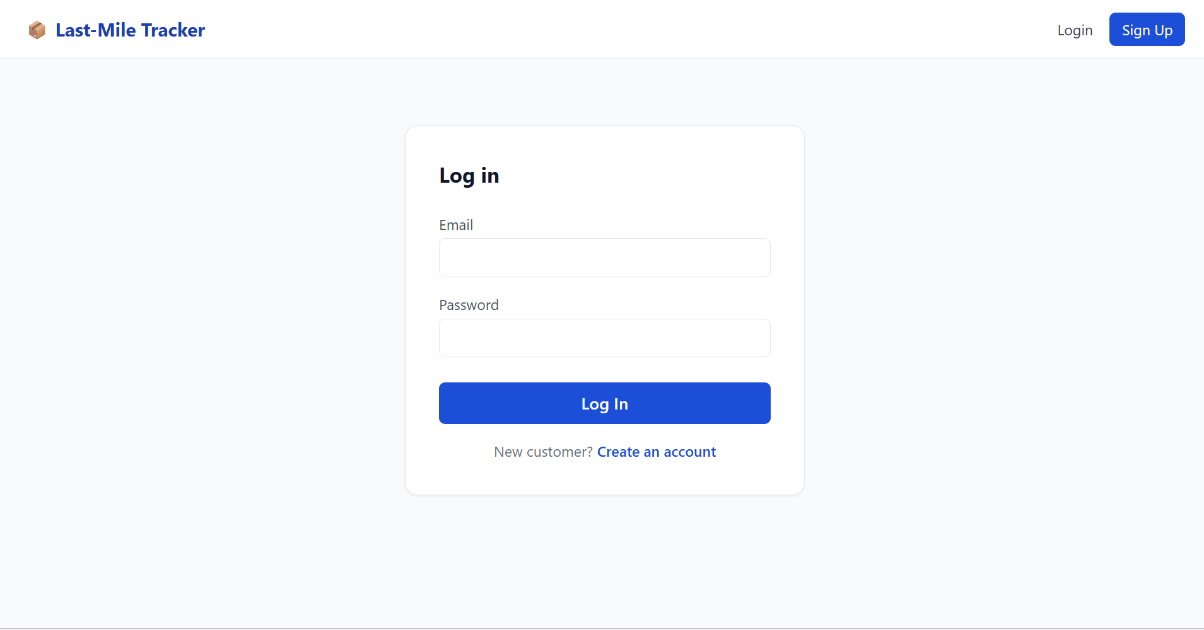
Login page
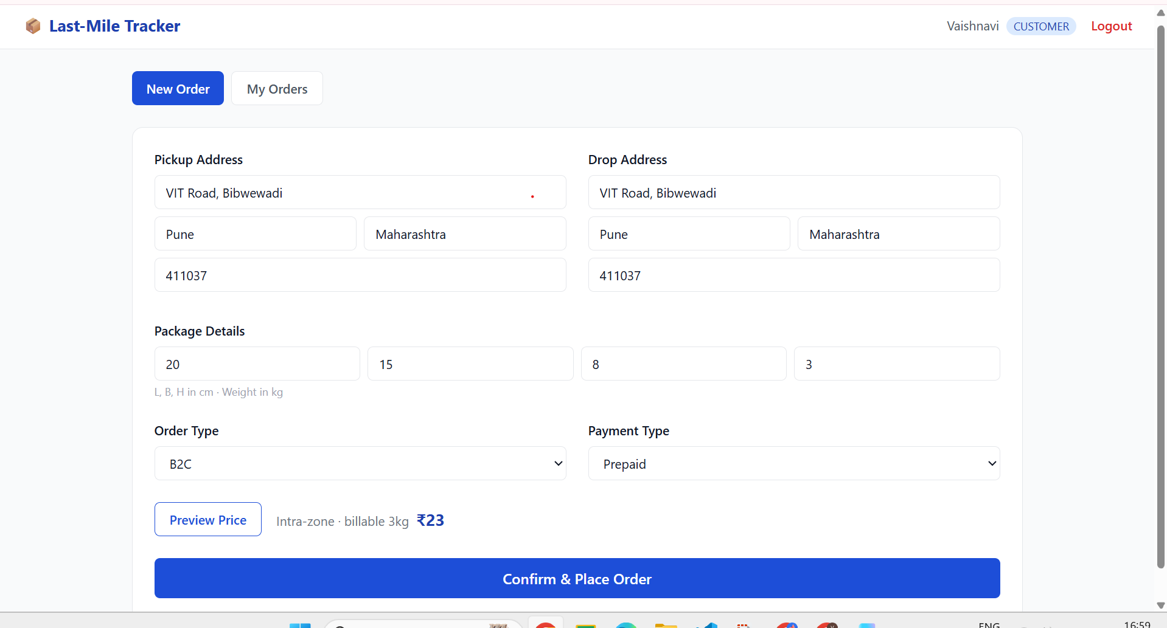
Customer — new order with live price preview
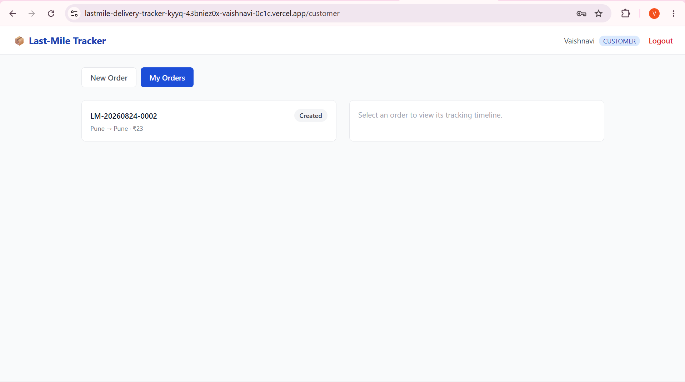
Customer — My Orders (tracking list)
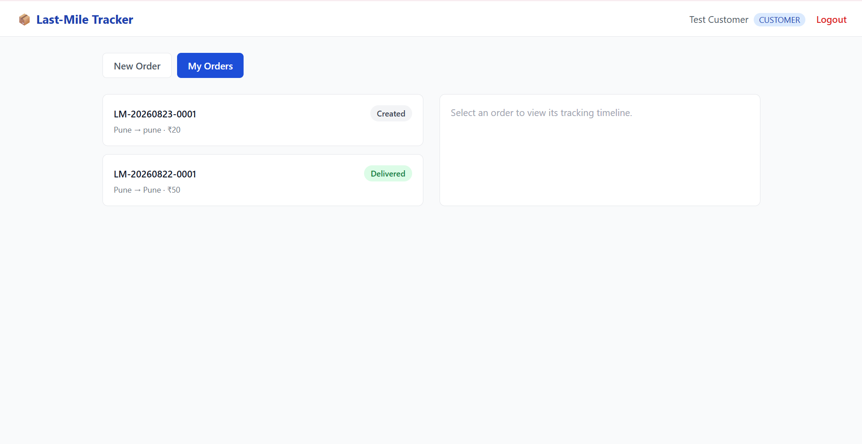
Customer — My Orders (multiple orders)
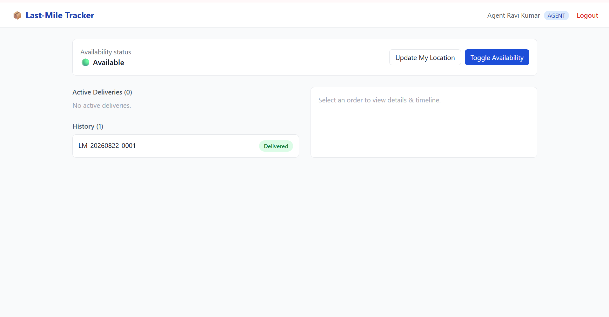
Delivery agent dashboard
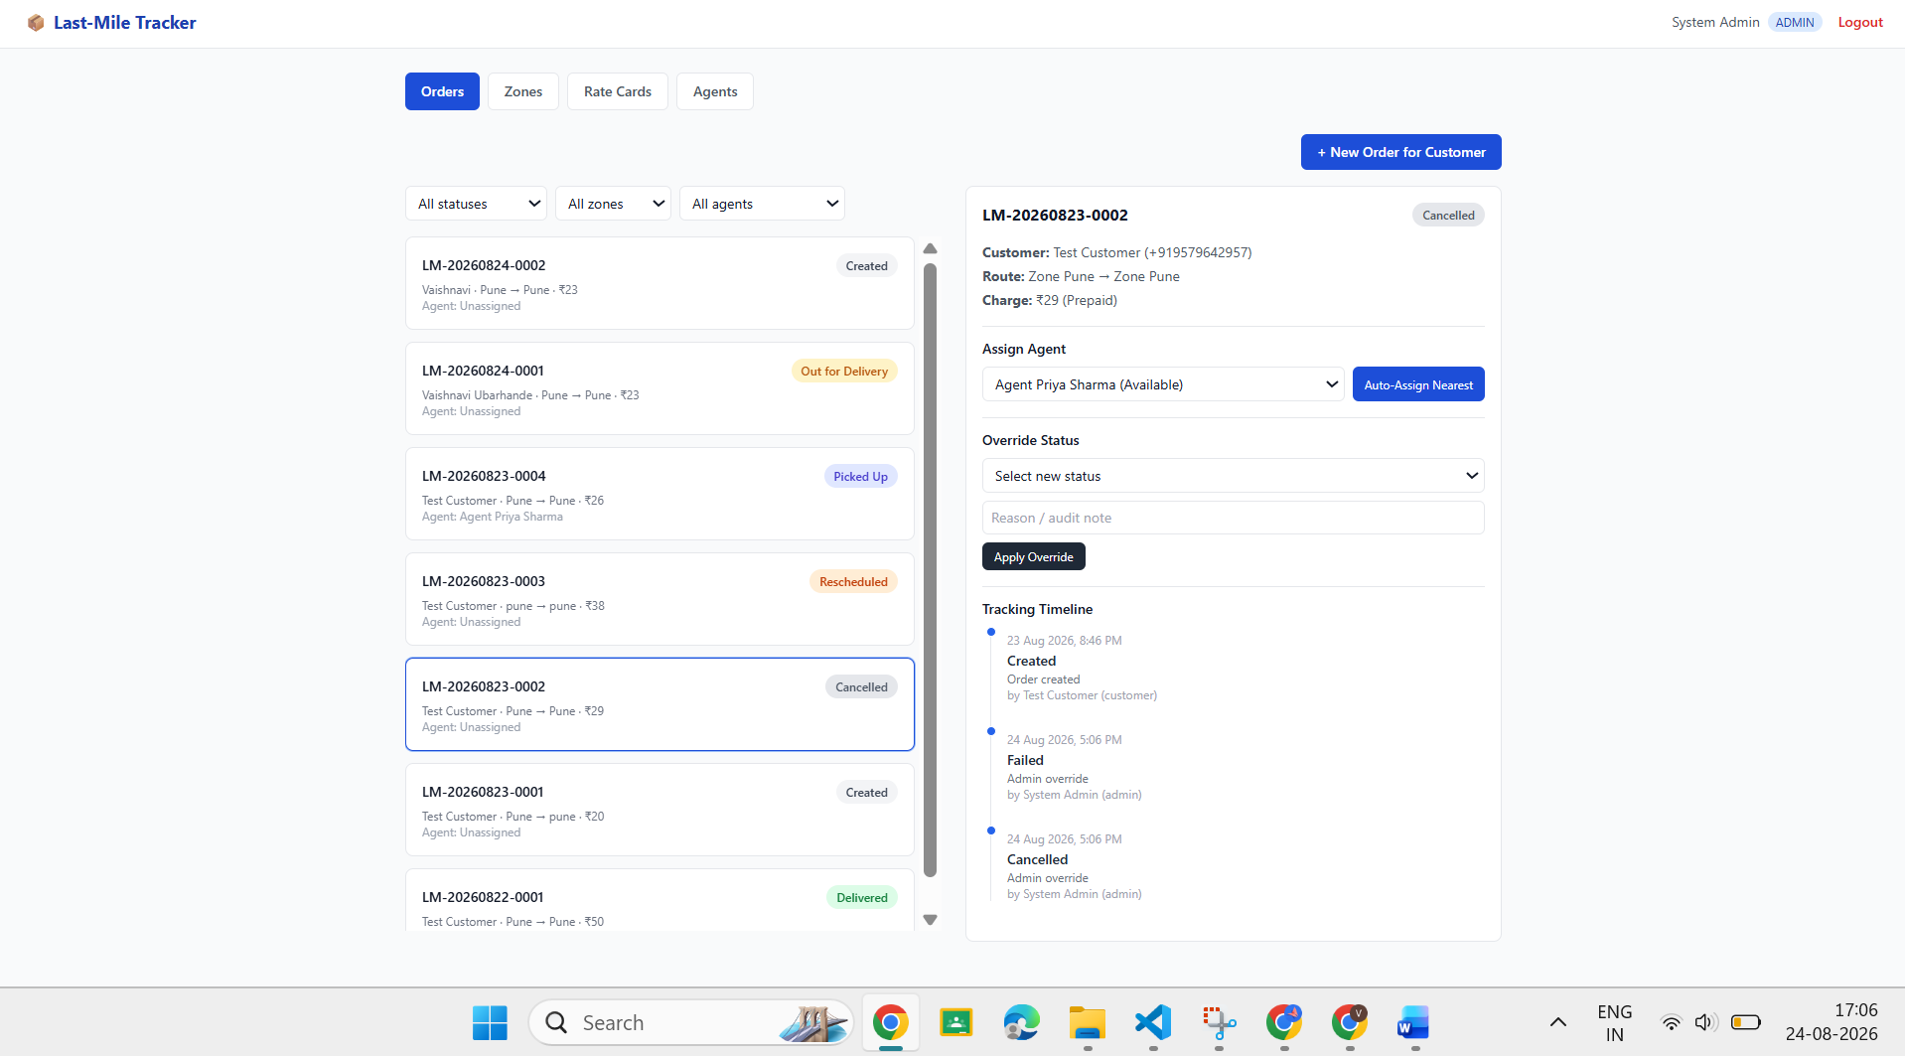
Admin — order management, agent assignment & status override

15. Conclusion
The Last-Mile Delivery Tracker demonstrates a complete, production-style logistics workflow: role-based authentication, a fully data-driven rate calculation engine, zone-aware routing, load-balanced nearest-agent auto-assignment, an immutable order-tracking audit trail, and automated customer notifications. Its modular backend design — with pricing, zone detection, and assignment logic implemented as independent, unit-tested utility modules — keeps the system maintainable, testable, and free of hardcoded business rules, making it representative of how real-world delivery platforms are engineered.

